Till now we’ve only seen binary classification, where the output class either +ve or -ve, or of two class only, but what if we have multi class output, as in MNIST we have 10 classes of output from 0-9.

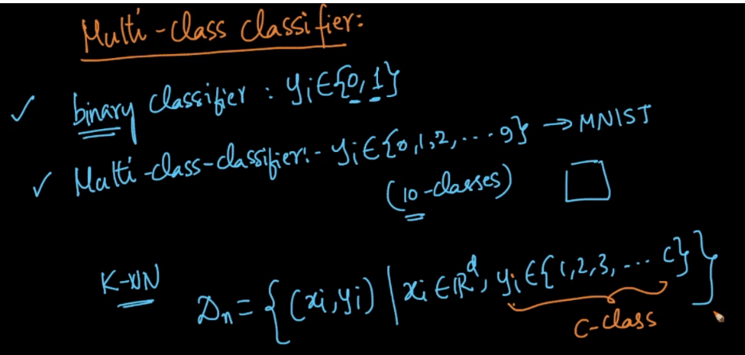

In KNN, it can be done easily as just by finding the majority vote for each class, class which have highest vote will be the output.

And for probability class also it can be done easily, example given below.

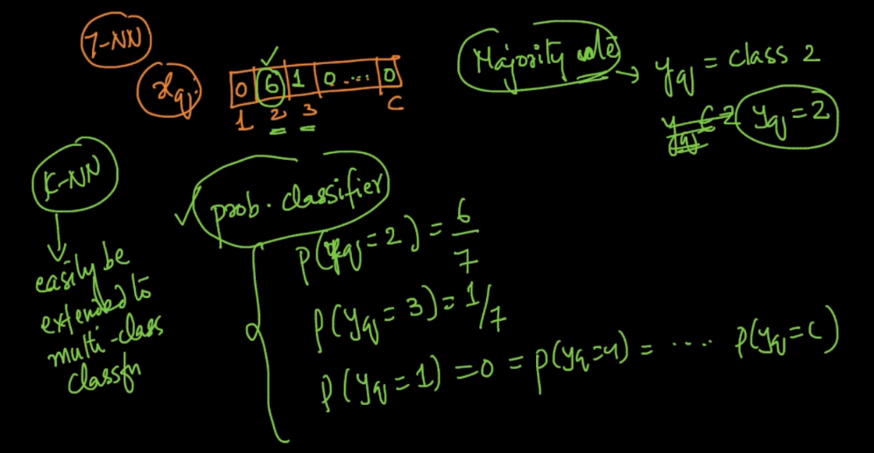

But all classifier algorithm can’t do multiclass classification easily as k-NN like logistic regression, so how we can implement multiclass classification for such classifiers.

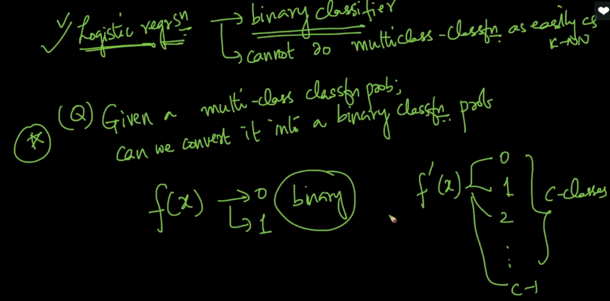

We can do this as: let’s say we have ‘c’ classes.

Now for each class we build a binary classifier, as for class 1, we’ll build a model with dataset as class is 1 or not, so the model will output whether the point is of class 1 or not.

Similaraly for class 2, , we’ll build a model with dataset as class is 2 or not, so the model will output whether the point is of class 2 or not.

And same we do for all classes.

So, finally we will have ‘c’ binary classifiers, and we’ll apply query point to all classifier until we get the result.

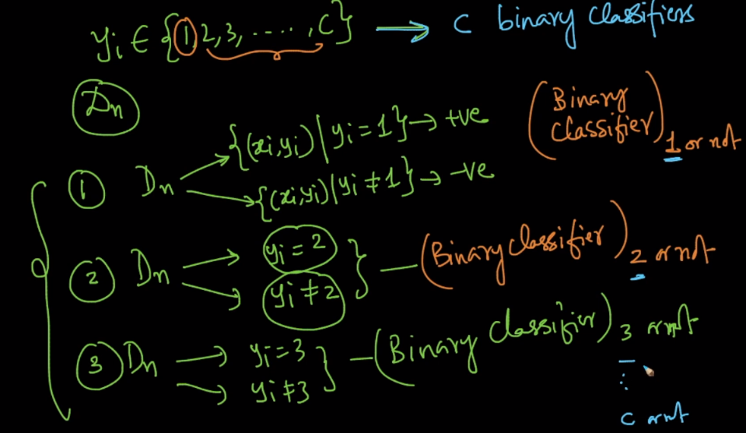

Such a way of creating one classifier for each class is also called **one vs rest classification.**

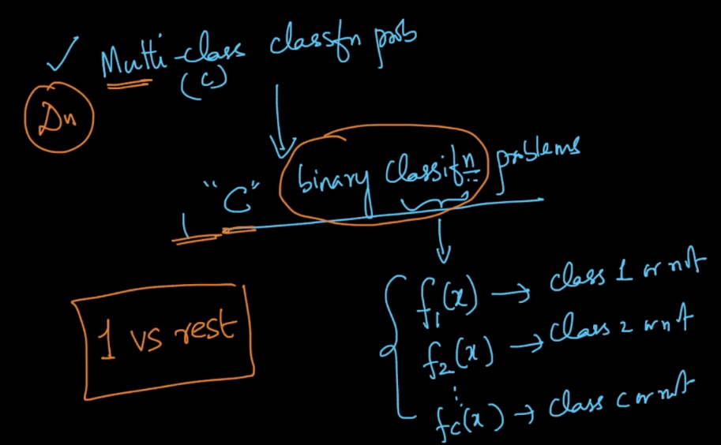

But ofcourse in such way time complexity and space complexity gonna increase.